**Could not calculate build plan: Failure to transfer org.apache.maven.plugins:maven-surefire-plugin:pom:2.7.1 from http://repo1.maven.org/maven2 was cached in the local repository, resolution will not be reattempted until the update interval of central has elapsed or updates are forced. Original error: Could not transfer artifact org.apache.maven.plugins:maven-surefire-plugin:pom:2.7.1 from/to central (http://repo1.maven.org/maven2): Access denied to http://repo1.maven.org/maven2/org/apache/maven/plugins/maven-surefire-plugin/2.7.1/maven-surefire-plugin-2.7.1.pom. Error code 407, Proxy Authentication Required ( The ISA Server requires authorization to fulfill the request. Access to the Web Proxy service is denied.  ) log4j-test01 Unknown Maven Problem**

解决方法如下：

（1）将C:\User\.m2\repository\org\apache\maven\plugins\maven-deploy-plugin目录下的文件夹删除，

（2）然后右击项目Maven->Update Project->Update Dependencies（如果更新无效，选择强制更新如下图）

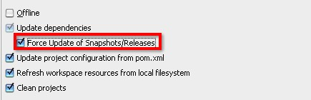

这样问题就解决了！